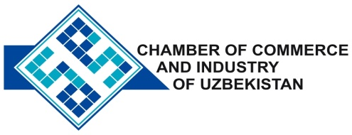

**Commercial offer of Uzbek Products to Foreign Buyer**

Dear Sirs, №TP-024

We offer quotation of Uzbek companies SP «Bars International Company».

**Information about the company:**

«Bars International Company» The Company was founded in 2005. The company specializes in the production of silk carpets.

**List of products:**

Silk carpets

**Benefits:**

Low price, high quality.

**Terms of delivery:** FCA Tashkent

If you are interested, we are happy to provide additional information in accordance with your request.

E-mail: export@chamber.uz

Website: www.chamber.uz

Export Promotion Department.

Chamber of Commerce of the Republic of Uzbekistan.